**Malek Esmail**

**National Clothing Chain**

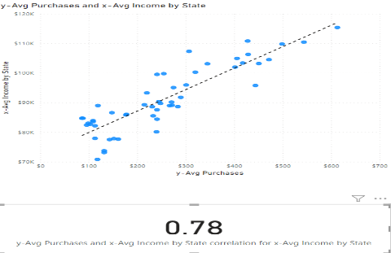

**What is the correlation (R2 value) between sales and income?**

0.78

**What is the correlation (R2 value) between customer ratings and product return rate?**

0.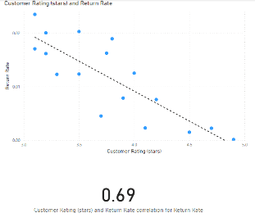69

**What are the linear regression formulas to predict customer sales and customer incomes?**

Y = 0.01 X + -722.67

**Which customer do you predict has the highest income?**

Jon Little

**Which product will be advertised the most?**

Gloves Winter or Sweater Cotton